# The Team

|  |  |  |
| --- | --- | --- |
| Liew Chun Tze Eldric | Ho Tack Kian | Ho Ze Wei Daryl |
| Nguyen Quoc Dat | Sim Shi Xian |  |

# Application Idea

## Description

Existing calendar and planning applications do not reflect the current state of technology, where most are merely online renditions of task lists or a calendar. Surely, these applications have brought great convenience to everyday users through synchronization and access through the Cloud, However, at DESK, we strongly believe there is much more unrealized potential untouched by current available calendar apps.

Firstly, not all tasks you do require a hard deadline. You may want to go to MacRitchie treetop walk at some unspecified time in the future; you may know of a good place where you want to visit with your old buddies to catch up; you may have some open Git issues that is non-critical and want to resolve some time next week. These are things you need to note down but yet do not want to set a date. Overlooking or forgetting these things can cause disappointment or worse, your friends, when you realize the window of opportunity is already over.

You might also want to fork out certain shared calendars and add your own information. Certain uses include Professors publishing a set of deadlines to his students, and students adding their own group meeting time.

Another major capability that has yet to be exploited is the automated calculation of how busy you already are. While you may be able to glance at your calendar and get a feel of how busy you are that week, you may underestimate (or overestimate) the contact time needed for each issues you have to resolve. By estimating your available capacity this week, we essentially help you manage your time with more convenience and accuracy.

These features can be integrated into the calendar and hence, we are introducing our app – Planendar. This app serves as the one-stop integrated platform for all your time planning needs, from remembering small details to when to solve issues to time management as a whole.

You will never want to use another organizer app ever again!

## Technical Details / App Type

The nature of the app is that of a standalone app. This allows for more freedom in our execution as well as the ability to integrate other APIs into our calendar. By using a standalone app, we can fully utilize all available space on the screen to ensure maximum user satisfaction. Most importantly, the scalability of our app will not be limited to just integration of Facebook events and user input, but the number of APIs we choose to include.

Using Node.js as the framework, we write plugins to integrate Facebook, Google Calendars and Github into the calendar.

# Execution Plans

|  |  |  |
| --- | --- | --- |
| Phases | Milestones |  |
| 0 | Set up AWS, Node.js, database | 16/8 |
| 1 | Produce Calendar view, Weekly view, Agenda view  Basic UI Design  Database schema completed  Basic Integration | 21/8 |
| 2 | Plugin system integration – Facebook, Gcal, Github  Meet Facebook aspirations (Graph queries, share, like, stories)  Permission system  Test data | 28/8 |
| 3 | Advanced functionalities (Search, permission, views)  Additional Plugins if possible | 4/9 |

# Application URL

<http://ec2-54-179-177-82.ap-southeast-1.compute.amazonaws.com/>

# SQL Schema

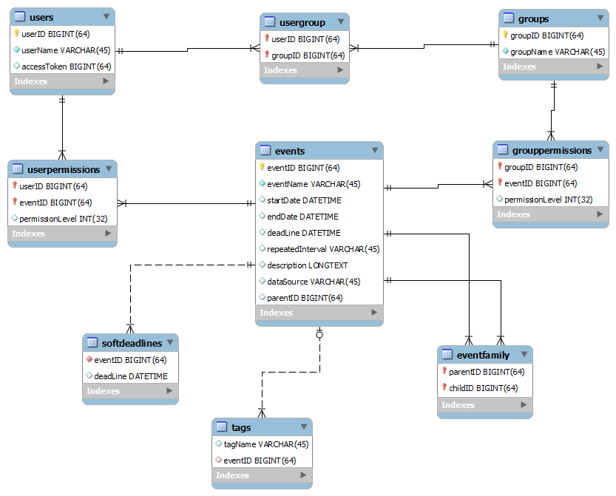

# Bonus Aspirations

**Bonus:** What are the pros and cons of each method of visibility control? When should one use the JavaScript method and when should one use the PHP method? (1%)

**Javascript** - element exists, just not visible

Pros: Server does less work, can actually unhide when u need it.

Cons: May not want to tell people who know how to view-source about your “hidden” features.

**PHP** - element does not exist.

Pros: People cannot know things you don’t send out.

Cons: You need to either reload or do an async request to get the data when you want to show

**Bonus:** What is the primary key of the home faculties table? (0.5%)

matric_no and faculty